   |    | AUDIT - ISO 27001 INTERVIEW | Version 1 : 21 avril 2026

CODE NACE
Informations juridiques de HIGH JACK

SIREN : | 899 198 543
SIRET (siège) : | 899 198 543 00030
Forme juridique : | SAS, société par actions simplifiée
Numéro de TVA : | FR33899198543
Inscription au RCS : | INSCRIT (au greffe de REIMS , le 20/05/2021 )
 | Voir 1 observation du greffe
Inscription au RNE : | INSCRIT (le 20/05/2021)
Numéro RCS : | 899 198 543 R.C.S. Reims
Capital social : | 19 715,00 €

Activité de HIGH JACK
Activité principale déclarée : | Edition de logiciels applicatifs
Code NAF ou APE (NACE) : | 58.29C (Édition de logiciels applicatifs)
Domaine d’activité : | Édition
Forme d'exercice : | Libérale non réglementée
Convention collective : | Bureaux d'études techniques, des cabinets d'ingénieurs-conseils et des sociétés de conseils - IDCC 1486
Date de clôture d'exercice comptable : | 31/12/2026

We also request the following documents:
Organizational chart / Functional chart
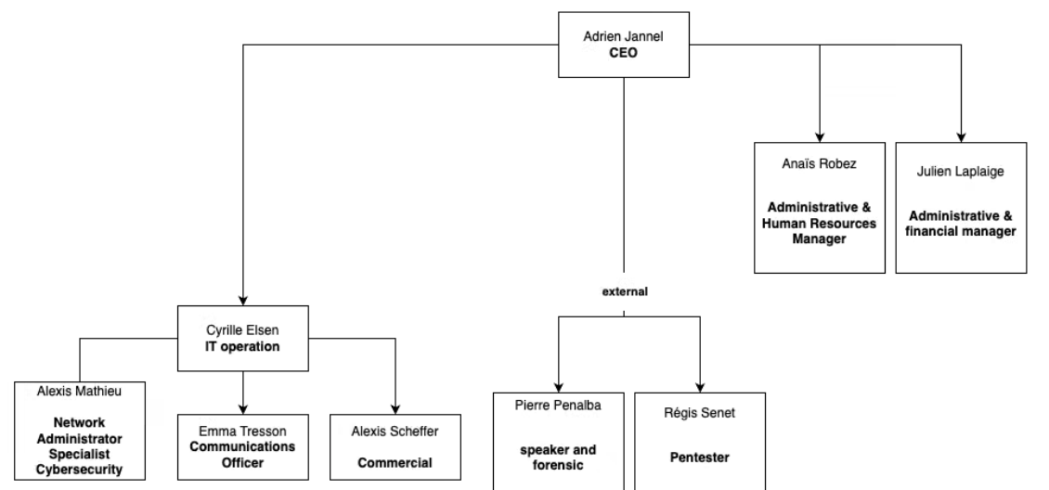
HIGH-JACK Organizational and Functional Chart
Official company profile document
Telephone user contract
Standard fixed lines : 3CX and SIP channels (Telco provider : TechOnme)
Mobile phones : telco provider : Alphalink
Data line contract
Two internet lines on two different Internet Service Providers (TechOnme And SAM informatique) . No single point of failure between the two lines.

How many physical or virtual servers do they have?
- 1 dedicated hosted server
- 7 virtual hosted servers
Service | Description | URL | Hébergement
Nextcloud | Data storage | cloud.zarflonix.fr | Serveur dédié OVH
Passbolt | Gestion des mots de passe | pass.zarflonix.fr | VPS OVH
3CX | Téléphonie | groupe-arjan.on3cx.fr | VPS OVH
OnlyOffice | Office Suite | office.zarflonix.fr | VPS OVH
Monitoring | Server monitoring | monitoring.zarflonix.fr | VPS OVH
SIEM (Wazuh) | Safety supervision | siem.zarflonix.fr | VPS OVH
Rapports Clients | Generation of performance client reports | Rapports.zarflonix.fr | VPS OVH
Plesk / Sites web | Web Hosting | site.zarflonix.fr | VPS OVH

How many VPNs?
No site to site VPN (only one office site)
Only VPN administrator to secure access to administration server tools on SSH protocol.
What software do they use and which is cloud-based?

All tools used by our company are cloud based
- Malibou (HR purposes)
- Hubspot (Customer Relationship Management)
- Pennylane (Accountancy Tool)
- NinjaOne (Endpoint management)
- Gravity Zone (EDR management)
- Canva (Presentation tool)
- EMA (Telco line management)
- Microsoft Office 365 (Office tools)

If the company develops software and what type?
The company does not develop any software.
A brief description of their customers, type, size, and risks.
Our customers are mainly small and medium-sized companies. Their risks are essentially linked to a lack of cybersecurity culture. We intervene with pentest and governance audits to help them get out of their risk areas.

If they have ever been subjected to cyber attacks.
High-Jack has not suffered a cyberattack that has impacted the confidentiality, availability or integrity of information
The privacy policy document.
The cyber risk assessment document.
Thank you.

